NATIONAL STORM SUMMARY

NOVEMBER 2006

5th-11th…A windy Pacific storm dumped heavy rain Monday on western Washington, killing at least one person, prompting warnings of record flooding and closing the main road in Mount Rainier National Park. A 20-year-old elk hunter from Seattle died when his pickup truck was swept into the Cowlitz River south of Mount Rainier, authorities said. Gov. Chris Gregoire declared a state of emergency for 18 counties, authorizing the National Guard to activate and the state Emergency Management Division to coordinate assistance. Officials at Mount Rainier National Park, which had 7 inches of rain Sunday and was expecting 10 more Monday, closed the main park road, turned visitors away and sent employees home early via the only exit road open. "We want to prevent visitors getting trapped inside the park. The road is vulnerable to washouts in several key places, and there is only one way out," superintendent Dave Uberagua said.
A sheriff's helicopter in Snohomish County, just north of Seattle, rescued
several transients stranded on a sandbar where they had been camping.
Evacuations were being encouraged in parts of Skagit County near the Canadian
border, with the Skagit River expected to reach record levels, county spokesman
Dan Berentson said. The National Weather Service warned county officials to expect worse conditions than in 2003, when flooding caused $17 million in property damage in Concrete and 3,400 households were evacuated, he said. Residents began showing up at one shelter by midday, and a hospital evacuated 15 patients as a precaution. The warm-weather rainstorms, propelled by air currents from Hawaii in a pattern called the Pineapple Express, could cause flooding of record proportions, the weather service said. Several rivers had already jumped their banks. The Army Corps of Engineers was sandbagging several rivers. At least 200 hunters were evacuated from about 65 hunting camps near the Cowlitz River. As of early Monday afternoon, Stampede Pass on the Cascade crest east of Seattle had 4 1/2 inches of rain in the previous 24 hours, while Seattle-Tacoma
International Airport recorded more than 2 1/2 inches. The forecast called for 6
to 10 inches in the Cascades and about 3 inches in the Seattle area in the 24
hours ending Monday night, with most rivers expected to crest Tuesday.
Record rainfall that brought heavy flooding to the Northwest, killing at least one person, causing evacuations and damaging roads and houses, began to ease Tuesday, as high waters continued to threaten some areas. Flood waters threatened nearly 300 homes and cabins in Washington after the Cowlitz River burst its banks and changed course near Packwood, south of Mt. Rainier, said Deputy Stacy Brown of the Lewis County sheriff's office. At least one house was swept away in the flood, she said. She said about 19 households in the area called for help, but mudslides and flooding had closed roads, making rescues more difficult. About 20 people spent Monday night in Packwood's Four Square Church, and more people were waiting Tuesday after being told their homes were imperiled by the changing river flow. About 200 to 225 elk hunters were evacuated Monday from hunting camps in the area, said Lewis County Sheriff Steve Mansfield. A 20-year-old hunter died when his pickup truck was swept into the river, authorities said. Tens of thousands of children were given the day off from school Tuesday. There were fears that voters in several Washington counties could have trouble reaching polling places Tuesday, although it wasn't immediately clear what problems, if any, they experienced. Most of the state's counties now vote entirely by mail. Rainfall records were set Monday across western Washington, including 8.22 inches at Stampede Pass, which broke an all-time rain record of 7.29 inches set on Nov. 19, 1962. Milder storms were expected later in the week but nothing as powerful as the storm that caused the flooding, said Brent Bower, a Weather Service hydrologist. Oregon Gov. Ted Kulongoski declared an emergency Tuesday in Tillamook County, where about 100 people were evacuated because of rising floodwaters. The Pineapple Express storm, named for its origin in warm Pacific waters, had dumped from 3 to 15 inches on Oregon by Tuesday, mostly on the coast and the northwestern corner of the state. Weather-related road closures were common, and affected parts of U.S. Routes 101 and 26. Election officials in Clatsop County arranged to have a dump truck pick up ballots Tuesday night in case of high water on roads. Three luxury homes in Gleneden Beach were on the brink of crumbling into the Pacific. On Tuesday morning, rock-loaded bulldozers and dump trucks tried to create a break to protect the homes from the high surf. West of Mount Hood, 17 homes in the town of Brightwood were evacuated because of the rising Sandy River. Most rivers and streams in the region were under flood watches or warnings. Rescuers used a boat to pick up seven illegal campers stranded by rising waters on the Sandy River delta near Troutdale, east of Portland. The area is known as a homeless encampment. More than 100 people were told to leave their homes in the northwest coastal town of Tillamook because of flooding, and all major roads in the area were closed, Undersheriff Terry Huntsman said.
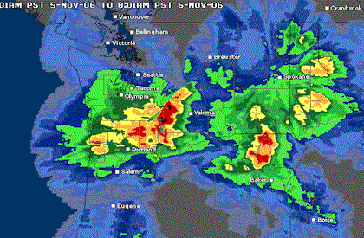
A storm dumped more than 4 inches of rain Wednesday on parts of New Jersey, flooding streets, sending small streams out of their banks and causing lengthy flight delays. Firefighters in at least two jurisdictions rescued people from vehicles stuck in floodwaters. No injuries were reported. Rain fell at a rate of 1 inch per hour at times. The National Weather Service issued flash flood warnings for several counties, and numerous highways were closed. Delays of more than three hours were reported at Newark Liberty International Airport late Wednesday afternoon.
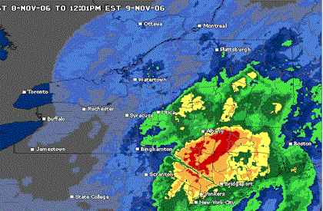

12th-18th...A strong storm caused wintry weather in the West. In the West, snow accumulation reached up to a foot in the Northern Rockies and High Plains, while up to 8 inches fell in the Cascades and Sierras. In western Washington, moderate to heavy rain pounded through the region and caused flooding conditions.
Two major storm systems pounded through the separate coasts on Tuesday. In addition, moist south winds triggered scattered precipitation across the central U.S. Out West, the large Pacific storm system that covered much of the West continued its eastward movement on Tuesday and carried a cold front southward through the southern two-thirds of the West. Rain and mountain snow persisted through Tuesday morning across the Great Basin, Rockies as well as northern and central California. Some heavy snow fell over the Central Rockies, especially along the west side of the slopes.
Lines of powerful thunderstorms pelted the South with heavy wind, rain and hail Wednesday, turning a skating rink into a hulk of twisted metal soon after the 31 preschoolers and four adults inside had fled to the only part of the building that turned out to be safe. One child suffered a broken bone and another a cut to the head, but everyone else emerged unharmed from the crumpled wreck of the Fun Zone Skate Center, which doubled as a day-care facility. Authorities were unsure whether it was a tornado that hit the skate center about 10:15 a.m.
Jon Slaughter, who owns two nearby businesses, arrived at the skating center
with two employees about five minutes after the building was ripped apart. The damage was so severe some witnesses were in disbelief that everyone inside could have walked out. Two people crawled under the beams and wreckage looking for kids, but everyone was already out. At least one tornado cut a path about two miles wide and three or four miles long in Greensburg, LA, toppling trees and damaging buildings and power lines, said Maj. Michael Martin of the St. Helena Parish Sheriff's Office. One man was killed when his home, a trailer covered by a wooden structure, was destroyed, he said. In Mississippi's Lamar County, emergency operations center director James Smith said a possible tornado struck a subdivision outside Sumrall at about 2:50 a.m. "It appears to be a tornado from the reports of damage we've received including 11 destroyed or damaged homes _ and from the track," Smith said. Smith said six people were taken to hospitals from the Sumrall area, and the Mississippi Emergency Management Agency said two other people were injured in Greene County. Along the Mississippi Gulf Coast, devastated last year by Hurricane Katrina, heavy rain flooded streets and closed some schools. City Hall in Biloxi suffered roof and water damage, and Mayor A.J. Holloway told The Sun Herald it appeared that a small tornado had touched down in the area. As the storms moved eastward, as much as 4 inches of rain fell in southern Alabama, flooding some homes, authorities reported. A tornado that hit a community in rural Pike County destroyed a volunteer fire department and knocked down a water tower, flooding the area where it landed, a sheriff's official said. A possible tornado tore through a community south of Montgomery, toppling trees, overturning a mobile home and knocking out power at a school. Storms overturned trailers in the southeast Alabama town of Elba, injuring several people, police investigator Tony Harrison said. In Arkansas, the thunderstorms toppled tractor-trailer rigs along Interstate 40 in Arkansas, and police said at least four people were hospitalized. Authorities said a hotel near Wheatley had structural damage. The storms caused flash flooding in Arkansas, including the Little Rock area, where police said they rescued two people who escaped high water by climbing trees. More than 3.5 inches of rain fell at Little Rock, including more than an inch in 20 minutes at the city's airport, the weather service said. Hail the diameter of quarters pounded areas west of the city.
A tornado flipped cars, shredded trees and ripped mobile homes to pieces in this little riverside community early Thursday, killing at least eight people, authorities said. The disaster the two-day death toll from a devastating line of thunderstorms that swept across the South to 12. Kip Godwin, chairman of the Columbus County Commission, said authorities had nearly concluded their search of the area where all the deaths occurred - a cluster of trailers and an adjacent neighborhood of brick homes - and had accounted for everyone. Hospital officials said four children were in critical condition. The storms that began Wednesday unleashed tornadoes and straight-line winds that overturned mobile homes and tractor-trailers, uprooted trees and knocked down power lines across the South. In Louisiana, a man died Wednesday when a tornado struck his home.
In South Carolina, a utility worker checking power lines Thursday during the storm was electrocuted. In North Carolina, two people died in car crashes as heavy rain pounded the state, dropping as much as five inches in some areas.
Off the coast, a Coast Guard helicopter lowered a pump to a fishing boat that was taking on water in 15-foot seas about 50 miles from Charleston. One crewman was aboard the 34-foot boat, which the Coast Guard escorted back to land. The tornado that struck Riegelwood - situated on the Cape Fear River about 20 miles west of Wilmington - hit shortly after 6:30 a.m. "There was no warning. There was no time," said Cissy Kennedy, a radiologist's assistant who lives in the area. "It just came out from nowhere." As many as 40 mobile homes were damaged before the tornado crossed a highway and leveled three brick homes. Some of the dead were believed to be children. Household debris, including carpet and a laundry basket, was scattered along a road. The storm dumped a minivan in a ditch, and an open refrigerator that still had food inside was filled with rainwater. County Commissioner Sammie Jacobs said four to five mobile homes were demolished, and there were "houses on top of cars and cars on top of houses."
"We've stepped across bodies to get to debris and search for other bodies here this morning," Jacobs said. The storm knocked out power to 45,000 customers in North Carolina. The storm also caused minor flooding in the Washington area, where rescuers grabbed several people stranded in their vehicles, and slowed commuters as far north as Newark, N.J.

19th-25th…Pounding surf and coastal flooding continued to batter the East Coast on Thanksgiving day as a powerful nor'easter drifted northward off the horeline.
The storm has been soaking the eastern Seaboard since Monday night, when strong winds picked up along the Southeastern Coast. The storm sat there until Wednesday night when it began to slowly move to the north and east, raising tides along the oceanfront and in the bays. On Thursday afternoon, tide gauges from Kings Point, NY to Money Point, VA were reporting tides high enough to merit high water advisories. In the Chesapeake Bay, tides were only just beginning to subside as winds turned offshore, helping push water out past the Chesapeake Bay Bridge Tunnel. In New England, storm winds were still on the rise Thursday afternoon. At Boston's Logan International Airport, winds were gusting to nearly 35 mph and were expected to continue to increase. Heavy rain was also becoming problematic throughout the Northeast, this Thanksgiving, with storm total rainfall accumulations well over 2 inches in many locations. A Pacific storm also continued to move ashore in the Northwest on Thursday, bringing heavy rain and some high elevation snow to Washington and Oregon. Clouds from this system spread east into the Northern Plains, and from there a cold front created a few clouds that dropped into the Four Corners states and Southern California. Despite these few high clouds, The Weather in California was gorgeous on Thursday with cool and crisp temperatures for most of the state, and nearly cloudless skies for the state with the exception of Extreme southern California.
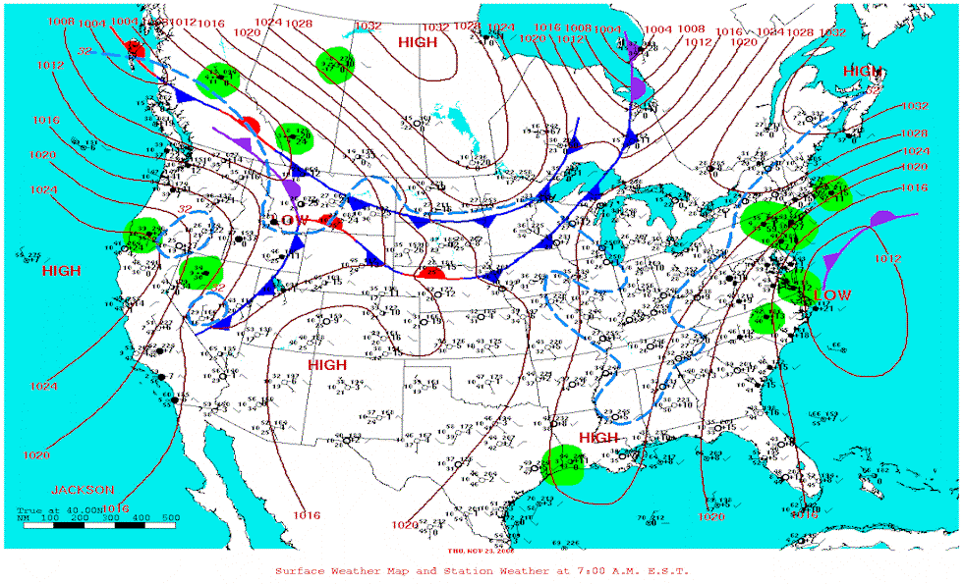

26th-30th…The storm that dumped as much as 2 feet of snow on some parts of Washington state turned freeways and city streets into icy gridlock and left thousands of people without power. The snowfall was capping off a month of heavy rain in Seattle _ which was edging closer to a wettest-single-month record. As of 10 p.m. Monday, Seattle-Tacoma International Airport, where official measurements are kept, had received 15.26 inches of precipitation just .07 inches short of the 15.33 inches recorded in downtown Seattle in December 1933.

"It's kind of ironic that after all that rain we could be breaking the record with snow," said National Weather Service meteorologist Danny Mercer in Seattle. "It doesn't happen this way very often." In central Washington, which received as much as 7 inches of snow, a Bridgeport woman and her two sons died in a two-vehicle crash near Orondo on Sunday evening. Roads were a mess by the Monday evening commute in Everett, north Seattle and Seattle's eastern suburbs, with cars sliding off Interstate 405. "There's cars in the ditches all up and down the road," said Don Bowman, who drove 20 miles to buy tire chains after he was unable to find any still available in his hometown of Blaine. Over the weekend, much of the heaviest snowfall had been in northwest Washington, with more than a foot falling in Ferndale by Monday morning. But later Monday, a low pressure system moved in over Island, Skagit and Snohomish counties, accompanied by an arctic front that pushed more snow south into Seattle and King County.
North of Seattle in Snohomish County, a total of about 40,000 customers were left without power, said Snohomish Public Utility District spokesman Neil Neroutsos. Rural parts of Skagit County, near the town of Concrete, reported 24 inches of snow Monday. Puget Sound Energy spokeswoman Dorothy Bracken said crews were working to restore about 100 small outages, each affecting one to seven customers, in Skagit, Whatcom, Island and Kitsap counties. In Seattle, Qwest Field, the home of the Seattle Seahawks, turned into a winter wonderland just in time for their Monday night game against the Green Bay Packers _ no strangers to harsh winter conditions. Steady snow began falling 20 minutes before kickoff.
In southwestern Washington, a tractor-trailer jackknifed on Interstate 5, causing a 14-car accident with no major injuries, said State Patrol Sgt. Monica Hunter.
A new storm headed into Washington state Wednesday as the region shivered in the aftermath of unusually heavy rain and snow that caused traffic nightmares and power outages. The stormy weather has been linked to two deaths. Joey Peplinski clears snow from his car in Avon, CO, Tuesday, Nov. 28, 2006. More than a foot of snow blanketed the Colorado Rockies early Tuesday and as much as another foot is expected by Wednesday.
Winter storm warnings were issued for much of the state into Thursday with up to a foot of new snow possible in the Cascade Range. One to 6 inches was predicted for the central Puget Sound area, including Seattle, the National Weather Service said. While much of the eastern third of the nation basked in readings in the 60s and 50s Wednesday, overnight temperatures in western Washington plunged into the low 20s. Two 16-year-old boys were found dead Tuesday in a garage east of Port Angeles in the Upper Peninsula, apparently the victims of carbon monoxide poisoning. They apparently were trying to refuel a portable generator used to supply power during a storm-caused blackout, said Jim Borte, a spokesman for the Clallam County sheriff's office. Elsewhere, Colorado was digging out after a storm dropped up to 2 feet of snow in the mountains Tuesday, replenishing ski resorts but making mountain travel treacherous. World Cup organizers canceled a men's downhill practice at the Beaver Creek resort near Vail, saying the racers _ who can exceed 70 mph _ couldn't see far enough in the heavy snowfall. They also cited the threat of avalanches. The rare Puget Sound snow that fell earlier this week turned commutes into nightmares. Some football fans reported spending eight hours or more getting home on icy roads after the Seattle Seahawks game, and others simply abandoned their cars on freeways. One to 3 inches of snow fell in Seattle, much of it during the Monday evening rush-hour, and as much as 5 or 6 inches in the surrounding suburbs, the weather service said. Up to 2 feet fell in the Cascade Range foothills, blacking out thousands of customers.
The first major snowstorm of the season blew across the Plains and Midwest on Thursday, grounding hundreds of flights, closing schools, glazing highways and threatening to dump up to a foot of snow on communities that had basked in balmy weather only days earlier. The wintry weather spread across an area stretching from Texas and Oklahoma to Michigan, and a blizzard warning was posted in parts of Oklahoma.
Clay Ender, who works for a heating service company, struggled to get around in the 3 inches of snow that fell overnight in Lubbock, Texas. A trip across the city that usually takes 20 minutes stretched to an hour, he said.
By Thursday, the storm was moving northeast from Oklahoma on the way to Illinois. It could reach the Northeast sometime this weekend. Sleet, snow and freezing rain forced the cancellation of 250 flights out of Dallas-Fort Worth International Airport. Some schools were closed. In the Texas Panhandle, roads were covered with ice and up to 7 inches of snow. At Chicago's O'Hare Airport, at least 265 flights scheduled for Friday morning were canceled. By Thursday afternoon, all but two departing flights from Lambert Airport in St. Louis had been canceled for the rest of the day. An Oklahoma man was killed Thursday when his vehicle skidded out of control on an icy road and hit an oncoming tractor-trailer, police said. In Springfield, Mo., freezing rain and sleet knocked out power to 15,000 customers, and the forecast called for snow and high winds.
Snow, Freezing Rain Moves Into Midwest

