NATIONAL WEATHER SUMMARY

NOVEMBER 2006

1st-4th…Very cold air filtered into the northern half of the country Wednesday. This meant afternoon temperatures only in the 20s and 30s in the Intermountain West and Northern Plains, and into the 30s and 40s in the Great Lakes, Central Rockies, and Upper Mississippi Valley. Elsewhere, a cold front meandered through the East, as the northern end moved towards the Northeast coast, while the southern end sprawled across the Gulf Coast. After only scattered showers in the morning, the front moved eastward and pulled a decent amount of Gulf of Mexico moisture northward into the Ohio Valley, Tennessee Valley, and Lower Mississippi Valley. This moisture instigated rain showers along with thunderstorms. The strongest thunderstorms were found across Mississippi and Alabama in the afternoon. This front also acted as a boundary between the warm air in the Southeast and the cold air stretching through the Mississippi Valley and farther northward. The Southeast coast rose into the 70s and 80s. Aside from light morning showers, the Northeast remained dry Wednesday. The region also saw varying temperatures from the 40s and 50s in western New England to the 60s in the east. The West remained dry Wednesday aside from some very light rain showers in Northern California early in the morning. The Northwest rose into the 40s and 50s, while California saw high temperatures. The Southwest rose into the 60s and 70s.
The first fairly major Pacific storm of the season moved into the Northwest on Friday, dumping steady rain and high-elevation snow. A few showers pushed into Idaho and western Montana but diminished by the afternoon. The eastern third of the country was dry and mostly clear, though some light lake-effect snow fell in western New England. Afternoon temperatures were in only the 30s and 40s from the Northern Plains through the Northeast.

5th-11th…Heavy rain pounded the Pacific Northwest on Tuesday, causing severe flooding in parts of Washington and Oregon. Scattered showers and isolated thunderstorms fell in the southern states, with areas of heavy rain in the Mid-Atlantic. Light to moderate rain also fell over the Ohio and Tennessee Valley all day. The eastern Great Lakes and southern New England saw rain developing by evening. It was warm and dry in the southwestern U.S., with temperatures reaching the 90s in some parts, and in the Great Plains, where temperatures ranged in the 70s and 80s.
An area of low pressure riding along the Northeast coast on Wednesday and produced a soggy day across the region Wednesday. As the low pulled in rich moisture from the Atlantic Ocean, 1 to 4 inches of rain poured down from the Delmarva to New England; a few locales received even higher amounts. Not only was a new daily rainfall record set at Islip, New York, but the deluge of rain
caused flooding throughout New Jersey. In addition to the heavy rain, gusty winds blowing around the low roughed up seas off the mid-Atlantic coast. Before the rain soaked the Northeast, the wet weather pushed through the Carolinas and
Virginias Tuesday and Tuesday night. Drier weather returned to these areas Wednesday; however, the presence of an upper-level low pressure center kept the region unsettled as clouds and spotty showers and thunderstorms persisted. To the west, the storm system that delivered the flooding rain to the Northwest earlier in the week shifted farther southward and eastward Wednesday. Farther away from the Pacific, the system lost a good deal of its abundant moisture; however, a bit of rain still wet some areas from the Upper Midwest to the northern Rockies and into central California. In the wake of this system, the Pacific Northwest could not enjoy rain-free weather as yet another system, weaker than the recent storm, arrived with some rain late in the day. The rain fell so heavily near Roseburg, Oregon, that visibility was reduced to a quarter of a mile on Interstate 5. In between the wet weather, a large ridge of high pressure brought unseasonably and record-breaking warmth to the Desert Southwest and the country's midsection. Several high temperatures went in the record books; some places even recorded their all-time record high for the month of November. When the temperature hit 80F in Denver, Colorado, not only was a new daily record high set, but it also marked the first time ever that the Mile High City has recorded an 80-degree temperature reading in the month of November.
In the East, areas of patchy morning fog began to dissipate across the Ohio and Tennessee Valleys, as well as the Deep South and Florida on Friday. A broad area of high pressure centered over the Mid-Atlantic allowed for fair and dry conditions across the rest of the eastern portion of the country. In the central portion of the country, a broad area of snowfall was located across the western Great Lakes and northern Mississippi Valley. Some moderate accumulations were reported, along with some breezy conditions. Curlew, Iowa, reported eight inches of snowfall and Manchester, Minnesota, reported nine inches. To the south of the snowfall, portions of Iowa reported scattered showers and thunderstorms, with a few reports of hail greater than three-quarters of an inch. Areas of patchy fog were dissipating across the southern Mississippi Valley. The southern Plains were under the influence of mostly cloudy, but dry, conditions. In the West, a Pacific storm system moved closer to the Pacific Northwest and created some spotty showers across the Pacific Northwest. Generally light accumulations of rain were reported. Areas of fog were reported across the northern and central Rockies, as well as the southern California coast. However, a broad area of high pressure centered over the Great Basin created fair and dry conditions across much of the western portion of the country.

12th-18th...A strong storm caused wintry weather in the West, while rain kept things gloomy from the middle of the country to the Northeast. In the West, snow accumulation reached up to a foot in the Northern Rockies and High Plains, while up to 8 inches fell in the Cascades and Sierras. In western Washington, moderate to heavy rain pounded through the region and caused flooding conditions.
Light to moderate rain fell across the Mississippi, Ohio and Tennessee Valleys,
and the western Great Lakes had a mix of snow and rain showers. In the East,
rain showers fell in New England and the Mid-Atlantic. Highs reached the 70s and 80s in the extreme South, while the Upper Midwest and western Great Lakes had temperatures in the 30s and lower 40s. Highs for the Northeast and Northwest were in the 40s and 50s.
Two major storm systems pounded through the separate coasts on Tuesday. In addition, moist south winds triggered scattered precipitation across the central U.S. Out West, the large Pacific storm system that covered much of the West continued its eastward movement on Tuesday and carried a cold front southward through the southern two-thirds of the West. Rain and mountain snow persisted through Tuesday morning across the Great Basin, Rockies as well as northern and central California. Some heavy snow fell over the Central Rockies, especially along the west side of the slopes. Around midday, the system pushed into the Plains and caused light snow to develop over the northern and central Plains.
Meanwhile, a ridge of high pressure built after the cold front across the Pacific Northwest and Northern California. This resulted in decreasing precipitation across the region in the morning and skies cleared out by noon.
In the East, the low pressure system off the New Jersey Coast early Tuesday moved northward into the New England Tuesday afternoon . It produced widespread cloudiness across the Great Lakes and Northeast all day. Moreover, light to moderate rain developed across the Northeast with the heaviest along the southern coast.
Finally, in the mid-section of the nation, scattered showers and thunderstorms developed across the lower and mid-Mississippi Valley on Tuesday. Some strong storms fired up over southern Louisiana and Mississippi in the afternoon and early evening.
In the East, a potent low pressure system generated scattered showers and thunderstorms across the lower Ohio Valley, Tennessee Valley, Gulf Coast states, and portions of the Southeast on Wednesday. Through the midday hours, multiple severe thunderstorm and tornado warnings were issued for parts of Mississippi and Alabama. In addition, rainfall in excess of two to three inches was reported in many areas. In fact, several locations across Mississippi and Alabama reported rainfall amounts in excess of three inches. To the north, areas of patchy fog gave way to partial sunshine across the Northeast, Mid-Atlantic, and into the coastal Carolinas. In the central third of the Nation, scattered showers and thunderstorms spread across Oklahoma and the southern half of the Mississippi Valley. Locally heavy rainfall led to the issuance of several flash flood warnings for portions of Arkansas and Louisiana. To the north, winds gusting to 60 mph were reported across Oklahoma. Elsewhere, a few light snow showers were observed in portions of eastern South Dakota and eastern Nebraska. In addition, a few areas of patchy fog were reported in the Midwest and the western Great Lakes. Conditions in the majority of Texas and the western Dakotas were dry with clear to partly cloudy skies. In the West, scattered showers and a few mountain snow showers moved over portions of the Pacific Northwest and the northern Rockies in response to a low pressure system off the Canadian Pacific Coast. Rainfall amounts in these areas were generally less than .50 of an inch. To the south, areas of patchy fog limited visibilities in portions of interior and coastal California. Conditions in the central and southern Rockies, Great Basin, and the Desert Southwest were dry with clear to partly cloudy skies.
A storm system that brought severe weather to the East the last few days finally made its exit from the Northeast into southeast Canada Friday, but not before it brought additional heavy rain to northern New England. This heavy rain fell ahead of the cold front as it moved northeast through the region. Flood Warnings and Flood Watches remained in affect for many streams and rivers in Maine due to more moderate to heavy rain. By late afternoon, the storm had sufficiently moved into Canada to allow precipitation to end in the Northeast. Meanwhile, breezy conditions continued through New England due to the storm. As one might expect, somewhat cool temperatures engulfed the Great Lakes and parts of the Northeast. Temperatures in the 30s and 40s were widespread in the Great Lakes and Upper Midwest, while 40s, 50s, and some 60s were experienced in the Northeast. The rest of the country remained mostly dry even as a weak cold front moved through the Rockies and Great Basin. Scattered clouds were noticed over the Rockies and Northwest, and temperatures rose into the 40s and 50s for these regions. The Southwest and Southern Plains were considerably warmer with temperatures in the 60s, 70s, and some 80s.

19^{th-}25th…In the East, a low pressure system off the Carolina Coast produced scattered showers and isolated thundershowers in that area as well as portions of the Southeast and the Tennessee Valley. No severe weather was reported, and precipitation amounts were less than one quarter inch. Elsewhere, mostly cloudy skies and dry conditions dominated the majority of the Northeast, Great Lakes, Ohio Valley, and the Appalachians. In the western two-thirds of the nation, a storm system produced mostly cloudy skies and widely scattered showers across portions of the Pacific Northwest, northern California, and the northern Rockies. Precipitation amounts remained under .50 of an inch in most places. To the south, dense fog remained in interior California. Conditions in the Desert Southwest, southern Rockies, Plains, Midwest, and the Mississippi Valley were dry with clear to partly cloudy skies.
Heavy rains pounded parts of the Mid-Atlantic states on Wednesday, while some areas higher up in the Appalachians had light snow. As the storms pushed northward, they brought rain to parts of southern and western New England.
Wet weather persisted in the Northwest, with a steady stream of cool showers falling in western Washington and Oregon and scattered showers peppering northern Idaho.
Snow advisories were in effect for portions of the northern Rockies and Cascades. Meanwhile, dry conditions dominated the Southwest, southern Rockies, Plains and Mississippi Valley. Temperatures were in the 30s and 40s in New England and ranged from the 40s to 60s in the Southeast. North Dakota and Minnesota saw temperatures in the 50s, while the Southern Plains had temperatures in the 70s. The Northwest and Intermountain West rose into the 30s.
Pounding surf and coastal flooding continued to batter the East Coast on Thanksgiving day as a powerful nor'easter drifted northward off the shoreline.
The storm has been soaking the eastern Seaboard since Monday night, when strong winds picked up along the Southeastern Coast. The storm sat there until Wednesday night when it began to slowly move to the north and east, raising tides along the oceanfront and in the bays. On Thursday afternoon, tide gauges from Kings Point, NY to Money Point, VA were reporting tides high enough to merit high water advisories. In the Chesapeake Bay, tides were only just beginning to subside as winds turned offshore, helping push water out past the Chesapeake Bay Bridge Tunnel. In New England, storm winds were still on the rise Thursday afternoon. At Boston's Logan International Airport, winds were gusting to nearly 35 mph and were expected to continue to increase. Heavy rain was also becoming problematic throughout the Northeast, this Thanksgiving, with storm total rainfall accumulations well over 2 inches in many locations. A Pacific storm also continued to move ashore in the Northwest on Thursday, bringing heavy rain and some high elevation snow to Washington and Oregon. Clouds from this system spread east into the Northern Plains, and from there a cold front created a few clouds that dropped into the Four Corners states and Southern California. Despite these few high clouds, The Weather in California was gorgeous on Thursday with cool and crisp temperatures for most of the state, and nearly cloudless skies for the state with the exception of Extreme southern California.
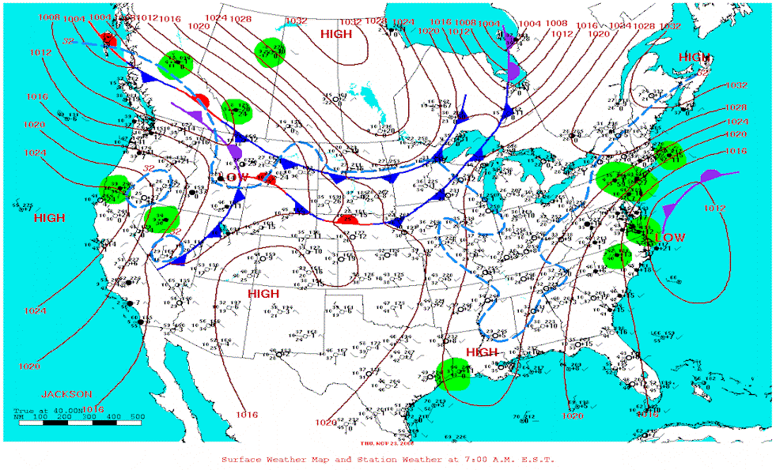
In the Northeast, skies finally cleared out on Friday after a couple of rainy days. This was due to the low pressure system off the New England's coast departed the region early Friday. The persistent rain across the southern New England decreased rapidly and by day break, rain completely ceased. Out West, the low pressure system that pushed onshore on Thursday continued its eastward movement and brought coastal rain showers and mountain snow from the Pacific Northwest through the northern Great Basin, Rockies and Plains. Since this system only has limited moisture to work with, much of the precipitation remained on the light side. Only parts of the coastal ranges received periods of heavy rain. Quiet the opposite, the rest of the West was dominated by a ridge of high pressure and partly cloudy to mostly sunny skies prevailed across the region. A very cold pool of air surged southward into the Northern Rockies and Plains and caused temperatures dropping into 10s and 20s in the afternoon. On the other hand, from the Great Plains to the Eastern Seaboard, it was a beautiful late autumn day. Away from the northern states, afternoon temperatures rose into the 60s and 70s with southern Texas soaring into the 80s.

26th-30th…In the East, high pressure dominated the weather pattern, producing partly cloudy and generally dry conditions for the Southeast, with some scattered showers. Rainfall amounts were minimal. A frontal system brought showers and thunderstorms to the Central Plains and Midwest, with some severe weather reported. 1.33 inches of rain fell in Lamoni, Iowa, while Enid, Oklahoma reported 0.77 inches. Scattered snow showers fell in the Northern Plains. Little to no snowfall accumulation was reported. Temperatures today were in the 50s and 60s in the Great Lakes and Northeast, reaching into the upper 60s and 70s across the southeast. Highs barely reached the 30s and 40s across the Northern Plains and western Great Lakes, but reached the 60s and 70s in the Southern Plains.
In the West, a low pressure system brought rain and mountain snow showers to the Intermountain West. Rainfall amounts were light to moderate. Heavy snow was reported in some areas, and thundersnow was reported in the Great Basin. 12 inches of snow was reported in Valley, Idaho, while Clallam, Washington received 8 inches. Lighter amounts were reported elsewhere. Highs were in the 20s and 30s in the Pacific Northwest, in the 40s and 50s across the Rockies and Southern California, reaching the 60s in the Desert Southwest.

